Chapter 3: Machine-Level Representation of Programs

Computers execute machine code, sequences of bytes encoding the low-level operations that manipulate data, manage memory, read and write data on storage devices, and communicate over networks. A compiler generates machine code through a series of stages, based on the rules of the programming language, the instruction set of the target machine, and the conventions followed by the operating system. The gcc C compiler generates its output in the form of assembly code, a textual representation of the machine code giving the individual instructions in the program. gcc then invokes both an assembler and a linker to generate the executable machine code from the assembly code. In this chapter, we will take a close look at machine code and its human-readable representation as assembly code.
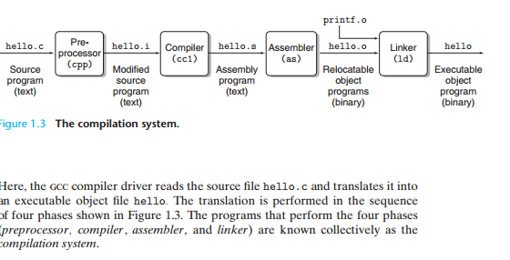
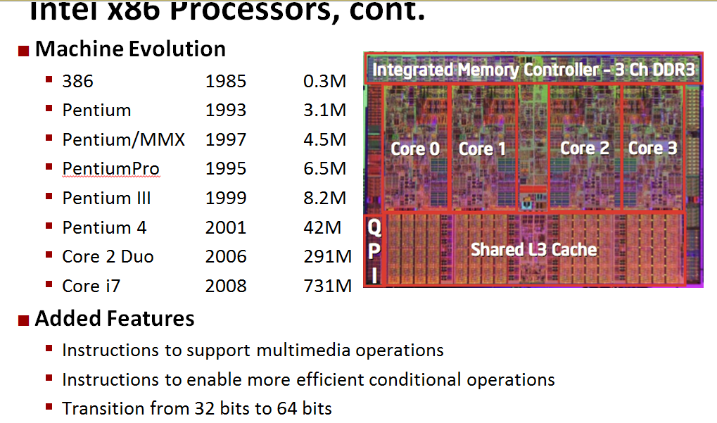
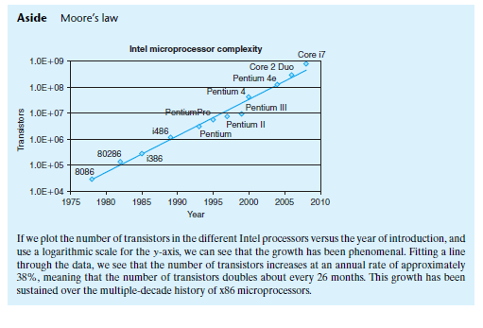

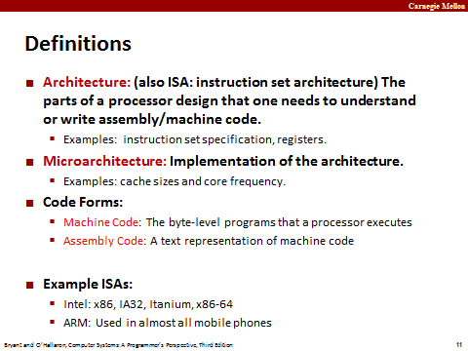
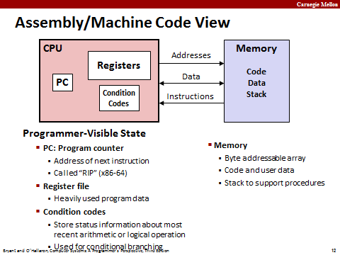
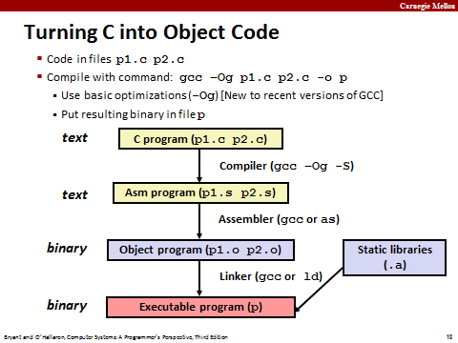
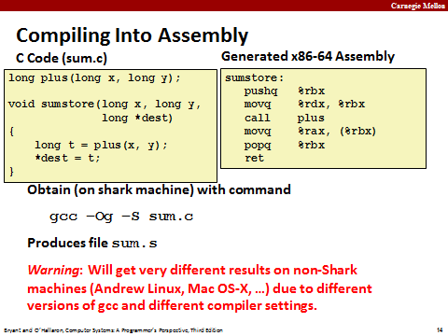
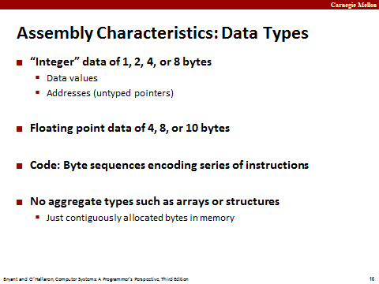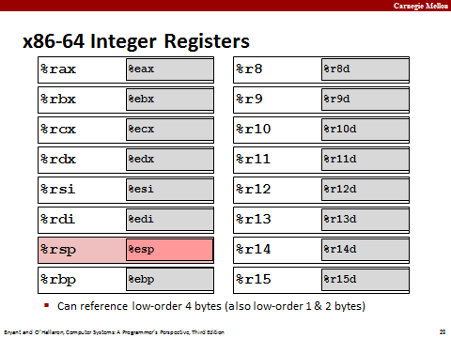
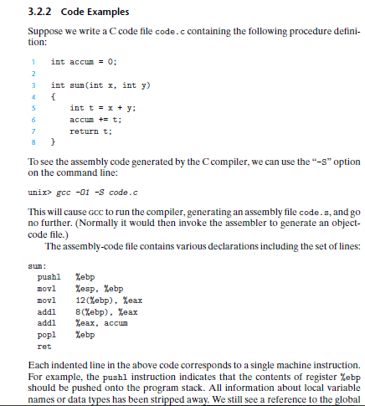

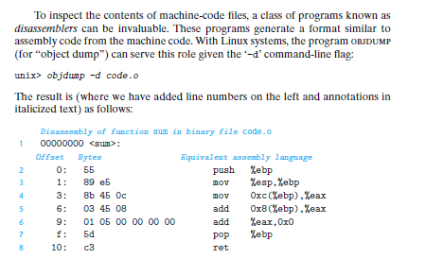
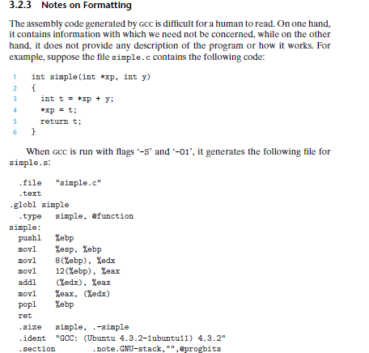
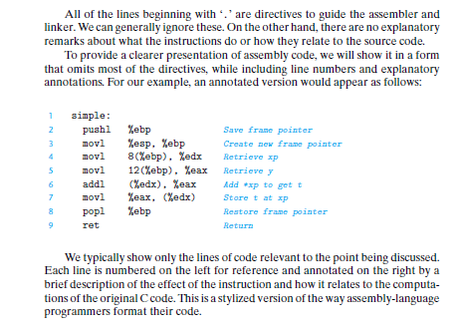
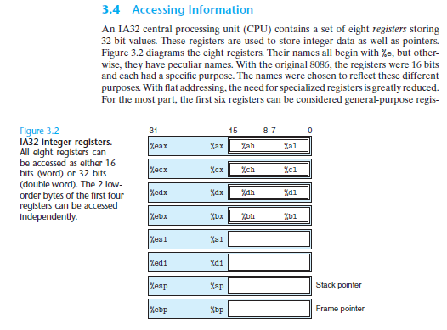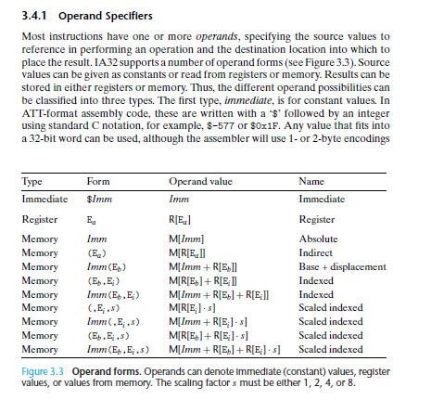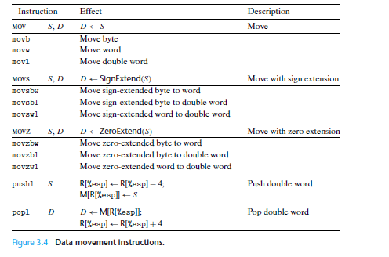
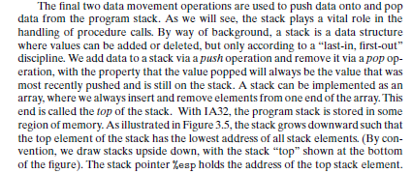
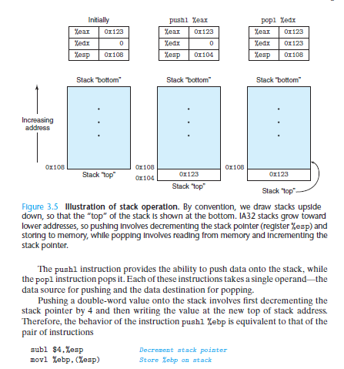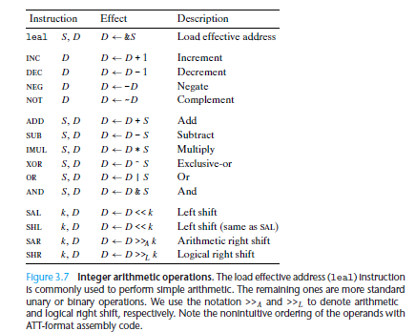
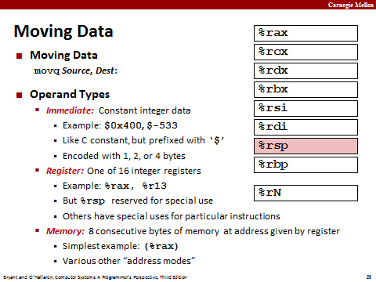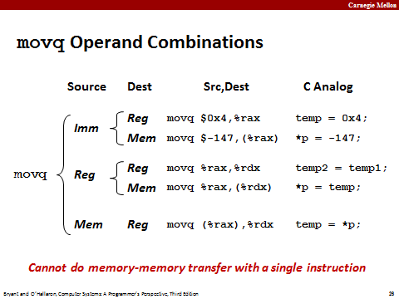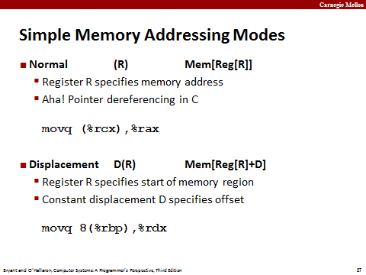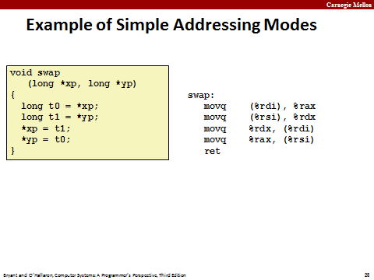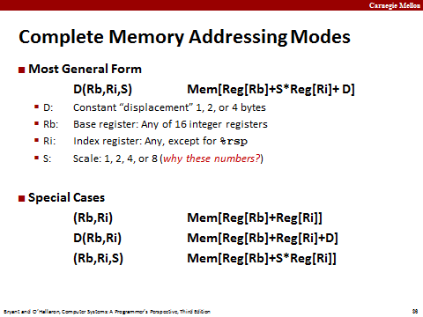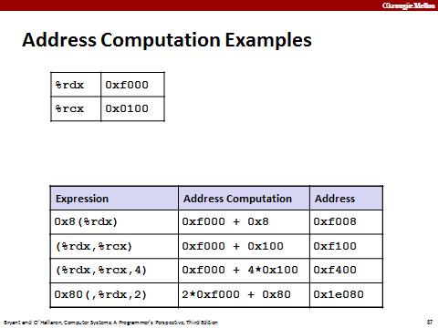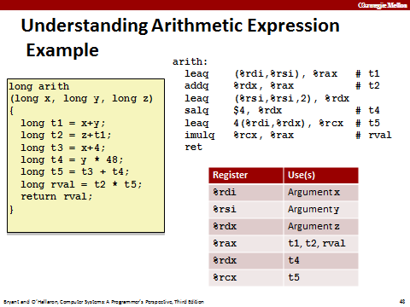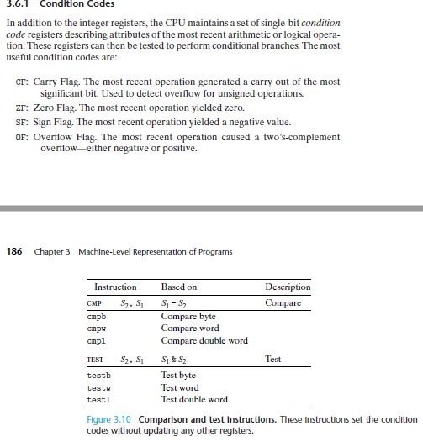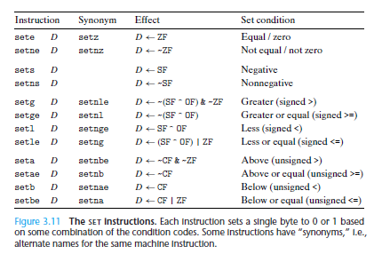

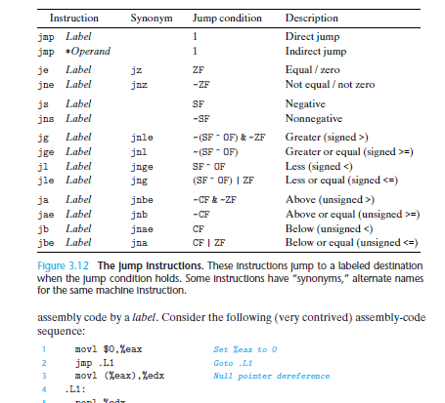

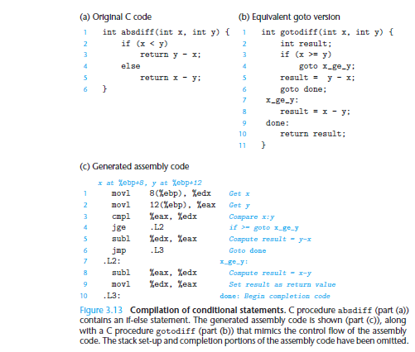
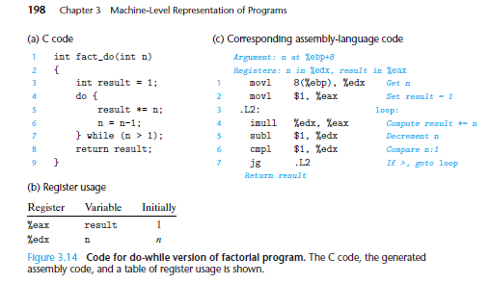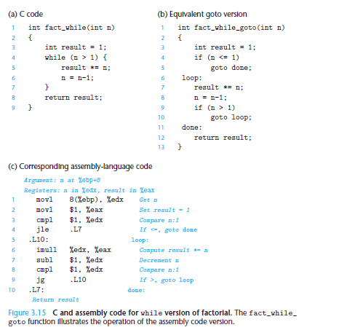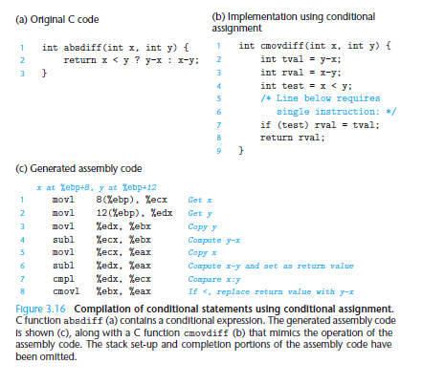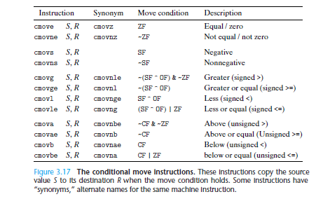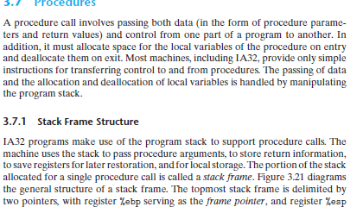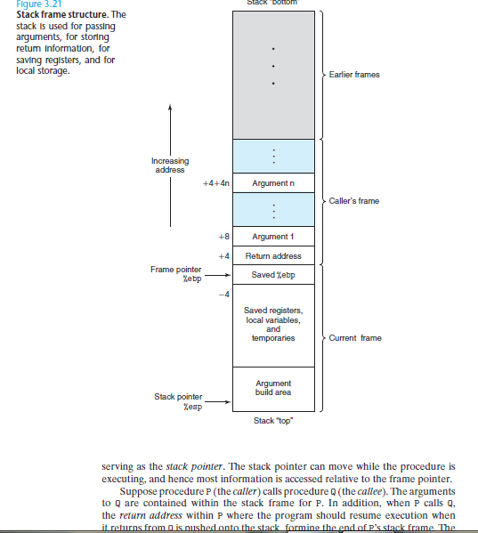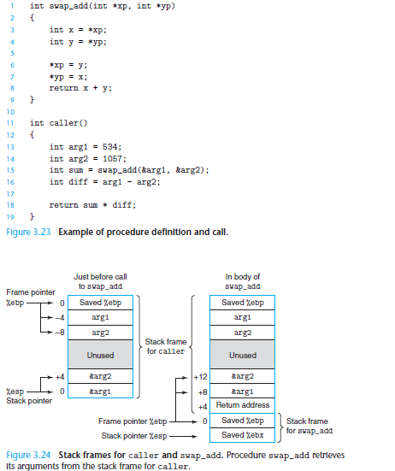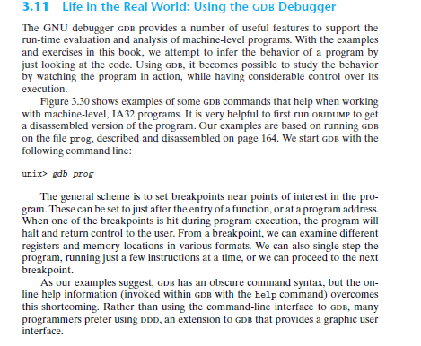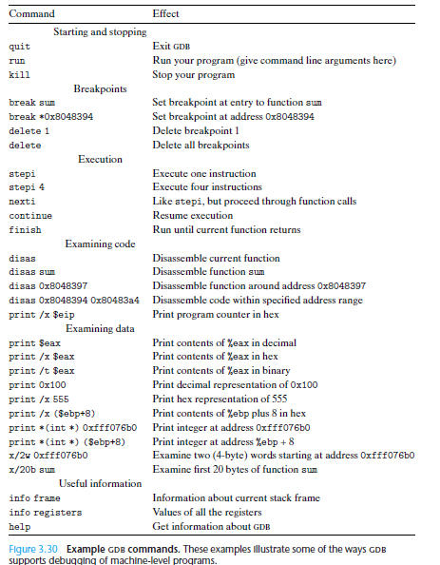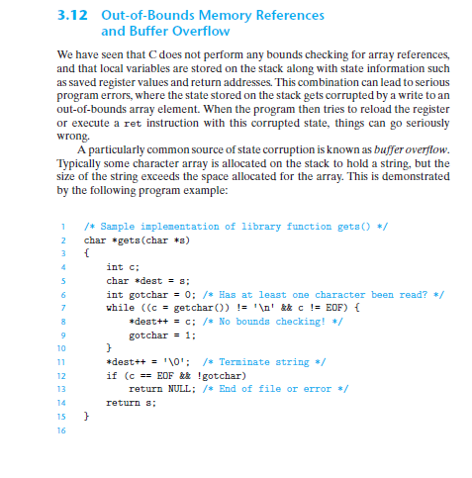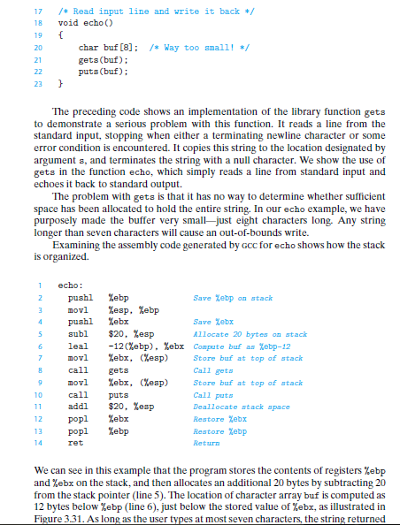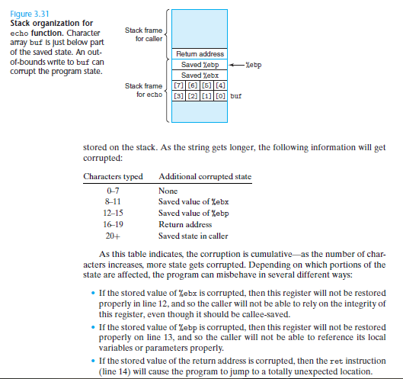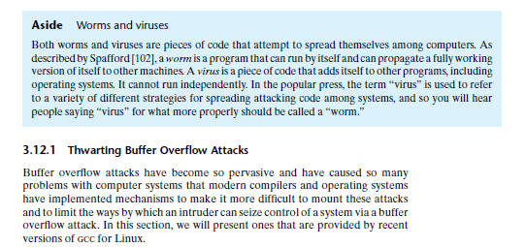

FUNCTION Call Stack and Activation Record
- The function call stack is the perfect data structure for handling this information.
- Each time a function calls another function, an entry is pushed onto the stack.
- This entry, called a stack frame or an activation record, contains the return address that the called function needs in order to return to the calling function.
- If the called function returns, instead of calling another function before returning, the stack frame for the function call is popped, and control transfers to the return address in the popped stack frame.
- The beauty of the call stack is that each called function always finds the information it needs to return to its caller at the top of the call stack.
- If one function makes a call to another, a stack frame for the new function call is simply pushed onto the call stack.
- Thus, the return address required by the newly called function to return to its caller is now located at the top of the stack.
- The stack frames have another important responsibility.
- Most functions have automatic variables—parameters and any local variables the function declares.
- Automatic variables need to exist while a function is executing.
- They need to remain active if the function makes calls to other functions.
- But when a called function returns to its caller, the called function’s automatic variables need to “go away.” The called function’s stack frame is a perfect place to reserve the memory for the called function’s automatic variables.
- That stack frame exists as long as the called function is active.
- When that function returns—and no longer needs its local automatic variables—its stack frame is popped from the stack, and those local automatic variables are no longer known to the program.
- The amount of memory in a computer is finite, so only a certain amount of memory can be used to store activation records on the function call stack.
- If more function calls occur than can have their activation records stored on the function call stack, an error known as stack overflow occurs.
- Consider how the call stack supports the operation of a square function called by main (lines 9–14 of Fig. 5.12).
- 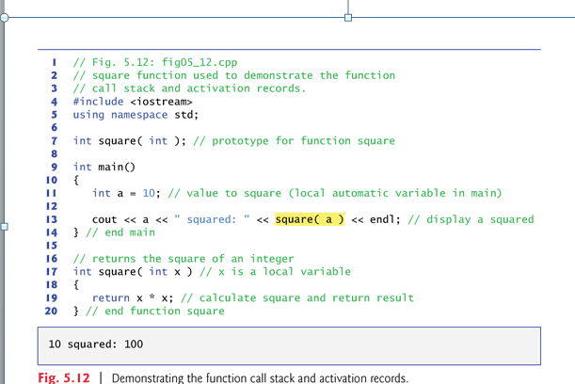

- First the operating system calls main—this pushes an activation record onto the stack (shown in Fig. 5.13).
- The activation record tells main how to return to the operating system (i.e., transfer to return address R1) and contains the space for main’s automatic variable (i.e., a, which is initialized to 10).
- Function main—before returning to the operating system—now calls function square in line 13 of Fig. 5.12.
- This causes a stack frame for square (lines 17–20) to be pushed onto the function call stack (Fig. 5.14).
- This stack frame contains the return address that square needs to return to main (i.e., R2) and the memory for square’s automatic variable (i.e., x).
- 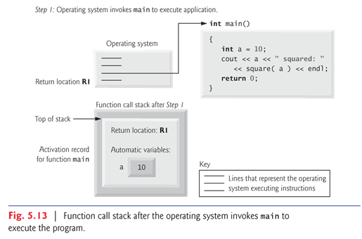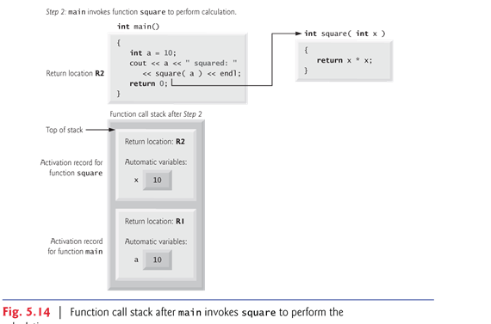
- After square calculates the square of its argument, it needs to return to main—and no longer needs the memory for its automatic variable x.
- So the stack is popped—giving square the return location in main (i.e., R2) and losing square’s automatic variable.
- Figure 5.15 shows the function call stack after square’s activation record has been popped.

- 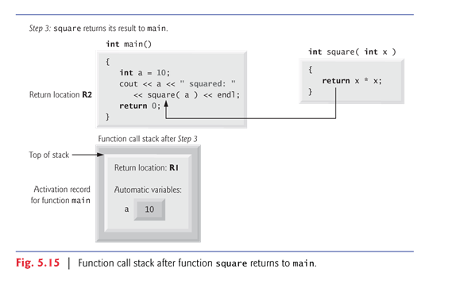
- main now displays the result of calling square (line 13).
- Reaching the closing right brace of main causes its activation record to be popped from the stack and gives main the address it needs to return to the operating system (i.e., R1 in Fig. 5.13) and causes the memory for main’s automatic variable (i.e., a) to become unavailable.
- You’ve now seen how valuable the stack data structure is in implementing a key mechanism that supports program execution.

